**Practical One**

**Reciever**

package practicall.one;

import java.io.*;

import java.net.*;

public class Receiver {

public static void main(String[] args) throws Exception {

String ct="",pt="";

ServerSocket skt=new ServerSocket(6017);

Socket sc=skt.accept();

int i=0;

System.out.println("Entered string ");

BufferedReader br= new BufferedReader(new InputStreamReader(sc.getInputStream()));

ct=br.readLine();

String[] s=new String[ct.length()];

s=ct.split(",");

int[] j=new int[s[0].length()];

System.out.println(" message:"+s[0]);

for(i=0;i<s[0].length();i++)

{

j[i]=Integer.parseInt(s[i+1]);

System.out.println(" key="+j[i]);

}

for(i=0;i<s[0].length();i++)

{

System.out.println("j="+j[i]);

pt+=(char)(s[0].charAt(i)-j[i]);

}

System.out.println("Message from Sender: "+pt);

}

}

**Sender.java**

package practicall.one;

import java.io.*;

import java.util.*;

import java.net.*;

public class Sender {

public static void main(String[] args) throws Exception{

String s="";

String ct="";

String key="";

Socket sc=new Socket("localhost",6017);

Random r=new Random();

int i=0,k=0;

System.out.println("Enter the string");

BufferedReader br= new BufferedReader(new InputStreamReader(System.in));

BufferedWriter bw=new BufferedWriter(new OutputStreamWriter(sc.getOutputStream()));

s=br.readLine();

int j[]=new int[s.length()];

for(i=0;i<s.length();i++)

{

j[k]=r.nextInt(50);

key+=Integer.valueOf(j[k])+",";

System.out.println("j="+j[k]);

ct+=(char)(s.charAt(i)+j[k]);

k++;

}

System.out.println(key);

System.out.println(ct);

bw.write(ct + "," + key);

bw.flush();

bw.close();

}

}

**Practical Four**

**Aim: Use DriveImageXML to image a hard drive.**

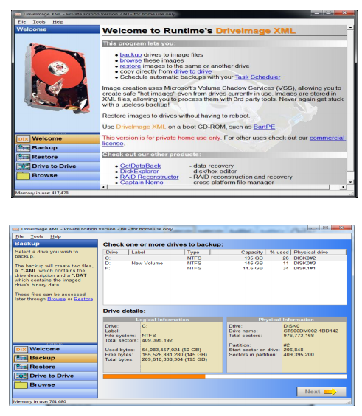

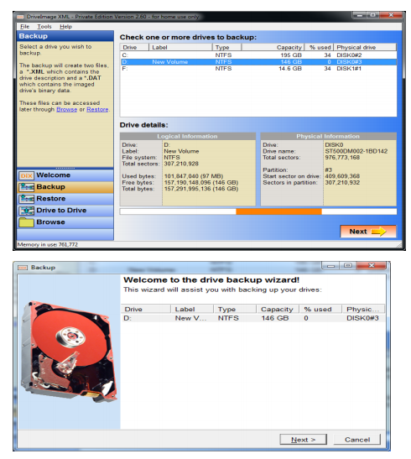

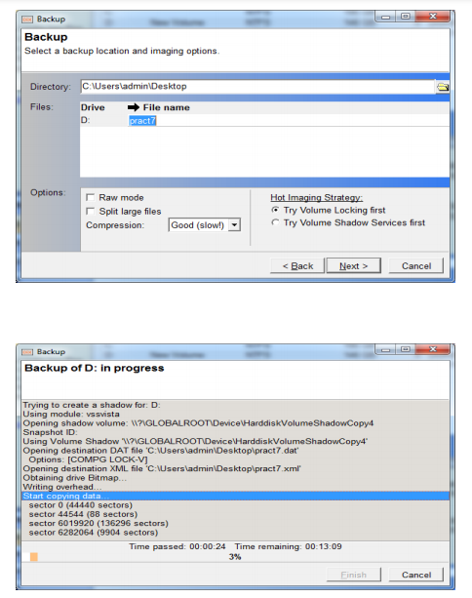

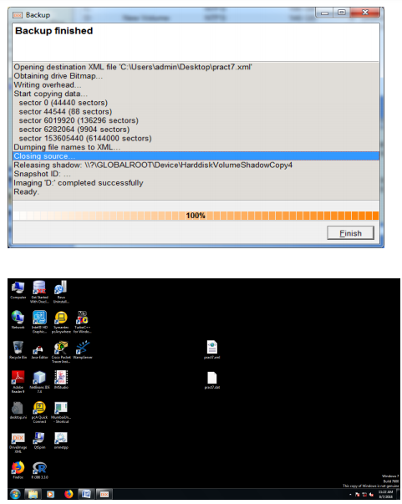

**Practical Five**

**Logger.java**

package practical.five;

import java.io.*;

import java.util.logging.*;

public class mylogger {

public static void main(String[] args) throws IOException {

Logger l=Logger.getLogger(mylogger.class.getName());

FileHandler fh;

try

{

fh=new FileHandler("c:/users/ankur/desktop/mylogfile.log",true);

l.addHandler(fh);

l.setLevel(Level.ALL);

SimpleFormatter sf=new SimpleFormatter();

fh.setFormatter(sf);

l.info("My first log");

}

catch(IOException e)

{

e.printStackTrace();

}

l.info("Hi How r u?");

}

}

**Practical Six**

**File Search**

package practical.six;

import java.io.*;

public class FileSearch {

public static void main(String[] args) throws IOException {

String d="";

final String f;

BufferedReader br=new BufferedReader(new InputStreamReader(System.in));

System.out.println("Enter the directory ");

d=br.readLine();

System.out.println("Enter the filter");

f=br.readLine();

File dir=new File(d);

FilenameFilter filter=new FilenameFilter(){

@Override

public boolean accept(File dir,String name){

return name.startsWith(f);

}

};

String[] children=dir.list(filter);

if(children==null){

System.out.println("Not found");

}else{

for(int i=0;i<children.length;i++){

String filename=children[i];

System.out.println(filename);

}

}

}

}

**Practical Seven**

**Search Word**

package practical.seven;

import java.io.BufferedReader;

import java.io.FileReader;

import java.io.InputStreamReader;

public class SearchWord {

public static void main(String[] args) {

try

{

String str="";

String ser="";

int flag=0;

BufferedReader br=new BufferedReader(new FileReader("C:\\Users\\ankur\\Desktop\\file.txt"));

BufferedReader br1=new BufferedReader(new InputStreamReader(System.in));

str=br.readLine();

String [] s = new String[str.length()];

System.out.println("enter the text u want to search");

ser=br1.readLine();

s=str.split(" ");

for(int i=0;i<s.length;i++)

{

if(ser.equalsIgnoreCase(s[i]))

{

System.out.println("Text "+ser+" Found");

flag=1;

}

}

if(flag==0)

System.out.println("Text "+ser+" Not Found");

}

catch(Exception e)

{

System.out.println(e);

}

}

}

**Practical Eight**

**Aim: Create forensic images of digital devices from volatile data such as memory using Imager for Computer System**

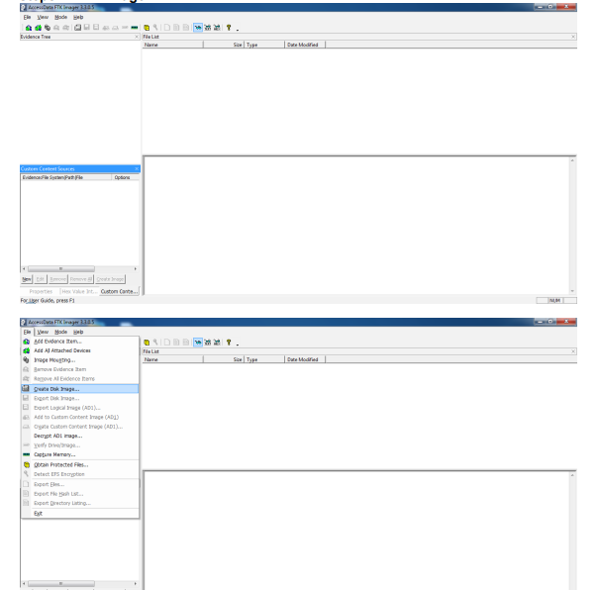

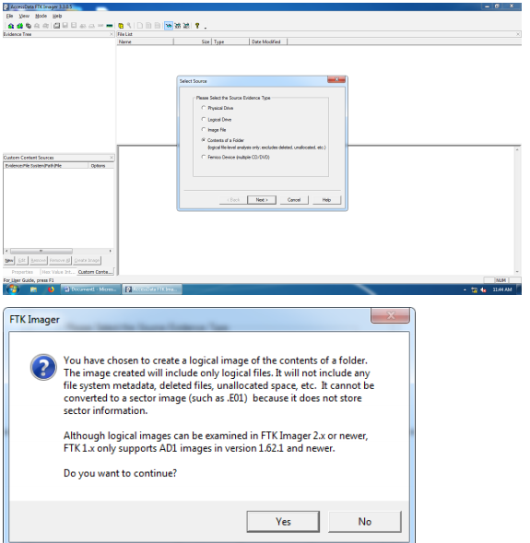

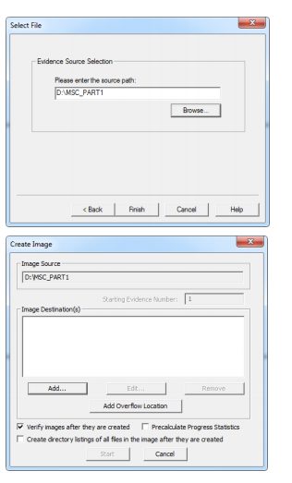

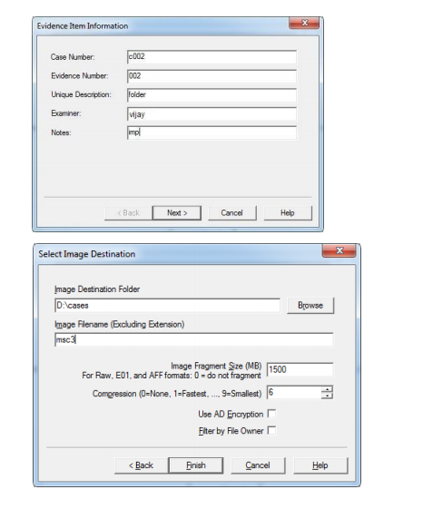

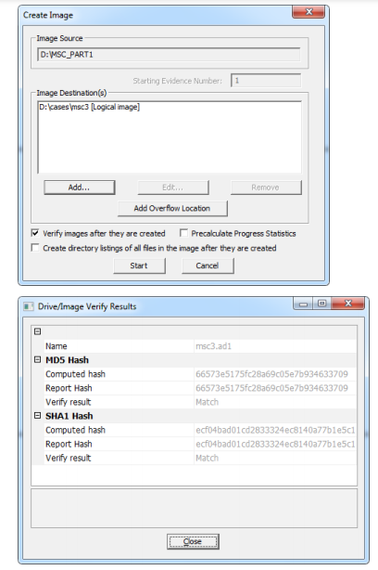

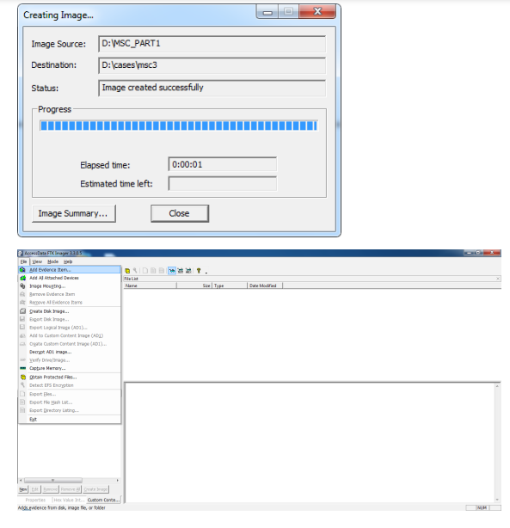

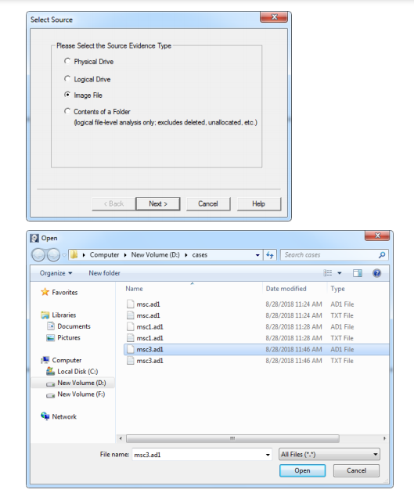

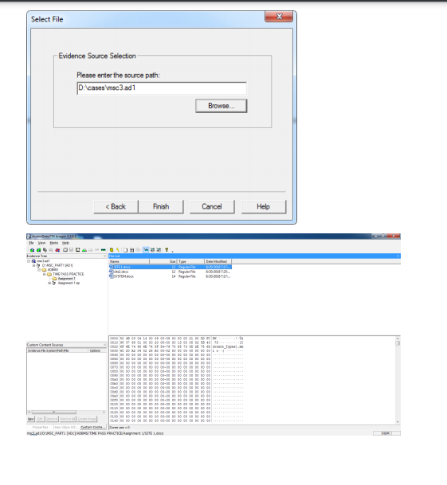

**Practical Nine**

**Aim: Registry Editor**

1. For wireless evidence in the registry:

hkey.localmachine.software.microsoft.windowsnt.currentversion.networklist.profiles

2. For recentdocs

hkey.currentuser.software.microsoft.windows.currentversion.explorer.recentdocs

3. For typed URLs

hkey.currentuser.software.microsoft.internetexplorer.typedurls

4. For IP Addresses

hkey.localmachine.system.services.currentcontrolset.services.tcpip.parameters.interface

5. For start up locations in the registry

hkey.localmachine.software.microsoft.windows.currentversion.run

6. For RunOnce startup

hkey.localmachine.software.microsoft.windows.currentversion.runonce

7. For start up services

hkey.localmachine.system.currentcontrolset.services

8.For start legacy applications

hkey.localmachine.system.currentcontrolset.control.wow

9. To start when a particular user logs on

hkey.currentusre.software.microsoft.windows.currentversion.run

10. For USB storage devices

hk.localmachine.system.controlsets00s.enum.usbstor

11. For mounted devices

hkey.localmachine.system.mounteddevices

**Practical Ten**

**Virus**

package practical.ten;

import java.io.FileWriter;

import java.io.IOException;

public class Virus {

public static void main(String[] args) {

try

{

FileWriter fw=new FileWriter("D:/virus.dll",true);

while(true)

{

fw.write("virus has been activated");

}

}

catch(IOException e)

{

e.printStackTrace();

}

}

}